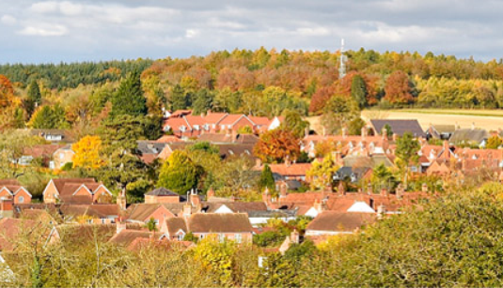 | Great Bedwyn Parish Flood Action Plan
Issue date
Document Reference | Final plan. Approved 13.7.23 Minute ref 614-23.10
Great Bedwyn lies to the east of Wiltshire and the River Dun and Kennet & Avon Canal run through the community. There is a history of flooding affecting the community which can be affected by river, surface and groundwater flooding. Surface water flooding in particular can happen very quickly and the parish council would encourage properties at risk to take steps before flooding occurs to increase the resistance of their properties to flooding. In view of the flood risk to the community the Parish Council has produced this Action Plan as part of its Emergency Plan. Most of the work in preparing for flooding should be done in advance. Residents and business are encouraged to assess their own risks, drawing on their own local knowledge, the information in this plan and other publicly available advice from the Environment Agency and Wiltshire Council.

The plan is intended as a guide to actions that the parish council, residents and business may take to reduce the impact of future flooding events. This plan, and its appendices updates the work of the Great Bedwyn Flood Group documented in the Great Bedwyn Flood Plan V2.0 dated 30 January 2014.

The parish council accept no liability for any loss or damage arising directly or indirectly from action taken or not taken in reliance on material or information contained with this plan, or for any failure to activate the plan or any part thereof in response to a flood. It is the homeowners responsibility to protect their property from flooding.
 | Action
Actions before a flood | - The parish council is enrolled into the Wiltshire Council PEAS enabling it to access flood defence equipment and has drawn up a sandbag policy in order to prioritise their distribution.  - The parish council participates in the “Ditch” letter scheme to encourage riparian owners to maintain their ditches and watercourses that if not maintained may cause internal property flooding.  - The parish council has drawn up a list of volunteers and contacts who may be called upon to assist in the event of an emergency.  - The parish council advises residents to check their flood risk and take steps to protect their property from flooding. To sign up to the met office/Environment Agency Flood & Weather Warnings.  - The parish council has identified areas/properties that are at risk of internal flooding and actions that may be taken to reduce that risk  - The parish council has identified a list of gullies that if blocked will cause internal property flooding and provided this list to the area highway engineer.  - The (Village Hall & Church) have been identified as places of refuge.  - Appendix 1 - Sandbag Policy  - Appendix 2 - Surface Water Flood Risk Map  - Appendix 3 - Historic Flooding & Remediation Works
Flood Alert    Monitoring Only | STAY SAFE  - Monitor local drains, ditches, surface water pathways and highways as identified in this flood action plan and report back any concerns to the community coordinator(s).
Flood Warning  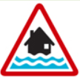  Monitoring & Prepare for Action | STAY SAFE  - Volunteers may undertake door knocking to inform residents that a Flood Warning has been issued.  - Meeting re access and distribution of flood defence items discussion  - Encourage residents to deploy flood protection products if available.  - Monitor, local drains, highways as above and take actions specified in plan  - Report concerns to coordinator in particular when properties start to flood.  Monitor extent and times of flooding for post event feedback if safe to do so.
Severe Flood Warning    Action | STAY SAFE  - Volunteers may undertake door knocking to inform residents and businesses that a severe flood warning has been issued – only if safe to do so.  - Contact refuge to advise key holder access may be required  - Provide information and support to emergency services if required.  - Assist Wiltshire Council, Environment Agency and Emergency services if requested. Volunteers should check with coordinator if concerned about request.  - If safe to do so monitor extent of flooding and provide information to enable feedback following incident.  - Keep assessing situation on ground and if weather/flooding conditions worsen volunteers will withdraw to place of safety advising coordinator of their actions.  Volunteer safety is paramount and they should not, under any circumstances, place themselves in danger, risk of harm or enter flood water.
Warnings no longer in force | - The parish council will assist with the clean-up process in advising residents of assistance available if they have flooded and where/who can provide information.  - Organise wash up meeting and assist setting up local meetings for residents with EA and Wiltshire Council to gather information.  - Ensure information about any flooding is gathered including number of properties internally flooded is collated and passed to Wiltshire Council/Environment Agency.  - Attend meeting to Review plan.

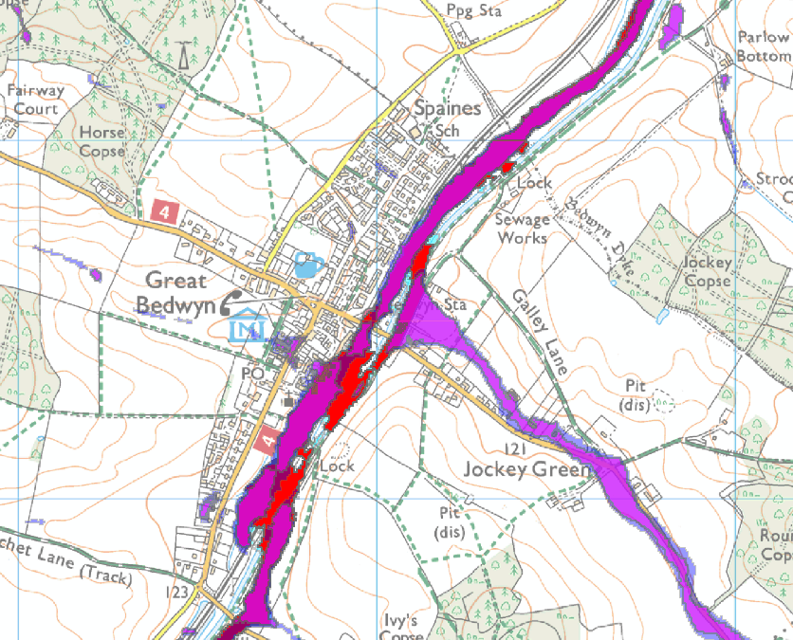

Surface and River Flooding Map Overview (for more information go to https://check-long-term-flood-risk.service.gov.uk/map)

Emergency Telephone contact details. (In no particular order)

Organisation | Telephone Number/contact details
Parish Clerk: Clair Wilkinson | clerk@greatbedwyn-pc.gov.uk
Parish Council Chairman: Bruce White | Bruce.white@greatbedwyn-pc.gov.uk tel 07308 996 154
Community Emergency Coordinator: | TBA
Great Bedwyn Flood Group Chair: Not applicable.
Floodline | 0345 988 1188  www.check-for-flooding.service.gov.uk)
EA Incident Line | 0800 80 70 60  www.gov.uk/report-an-environmental-incident
Gas Emergency | 0800 111 999  www.britishgas.co.uk
Thames Water Sewer Flooding Hotline | 0800 316 9800  www.thameswater.co.uk/help/emergencies/sewer/flooding  Wessex Water Sewage Floodline: 0345 850 5959 (24 hours)  Wessex Water Leak stoppers: 0800 692 0692  Email: operational.enquiries@wessexwater.co.uk  Website: www.wessexwater.co.uk  Thames Water Water or Waste Waterline: 0845 9200 800  Thames Water Leak Line: 0800 714 614  Website: www.thameswater.co.uk  Southern Water Emergency line: If you have a water supply or wastewater emergency, including blocked drains or wish to report a possible pollution, please contact 0845 278 0845 (open 24 hours for emergencies)  Southern Water emergency line: 0800 820 999 (24 hours)  Website: www.southernwater.co.uk
Wiltshire Council – imminent danger of flooding (sandbags) | 0300 456 0105  emergencyplanning@wiltshire.gov.uk  www.wiltshire.gov.uk/civil-emergencies-who-to-contact
Emergency –Police, Fire & Rescue, Ambulance | 999
Police (Inform & report non-emergency) | 101

