Great Bedwyn Neighbourhood Development Plan Sustainability Appraisal Scoping
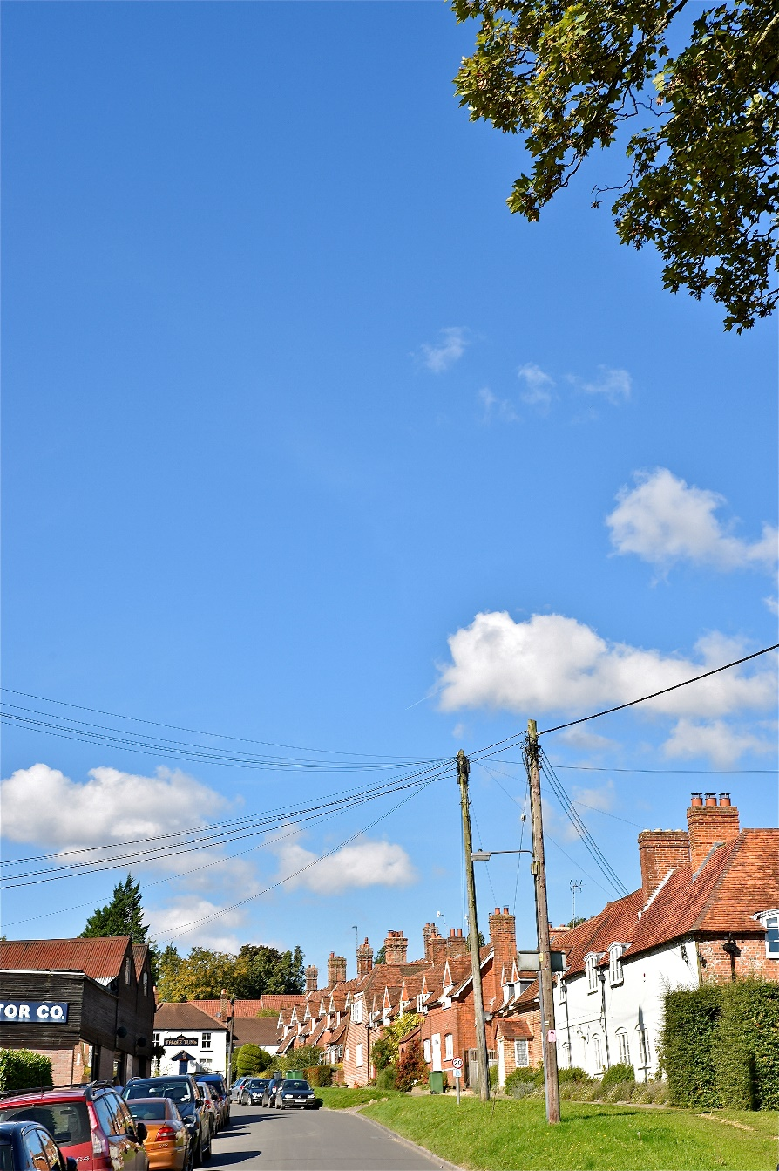

GREAT BEDWYN NEIGHBOURHOOD DEVELOPMENT PLAN (GBNDP) SUSTAINABILITY APPRAISAL SCOPING
1. Introduction

Great Bedwyn
The Civil Parish of Great Bedwyn stands at the centre of the North Wessex Area of Outstanding Natural Beauty [insert AONB map]. This location, and the linked history of local community development, are the defining features of the Parish [insert Parish map]. About a quarter of its 1679 hectares are woodland (Forestry Commission and privately owned, ancient and secondary). The woodlands are home to several protected species of fauna. Most of the remaining hectares are agricultural land (about half) and parkland. A wetland important to wildlife (the River Dun and the Kennet and Avon Canal) bisects the lower-lying centre of the Parish.

The population of the Parish is about 1400. The principal settlement is the village of Great Bedwyn, with outlying hamlets at Crofton and St Katherine’s, and many more isolated homes in the wooded areas. The County and Parish boundaries in this region have changed periodically since 1895, and the Village has grown, so that it now lies hard against the north-eastern border of the Parish, looking up north-westwards to the Iron-Age fort of Chisbury and the adjacent woodlands, and southwards to the Bedwyn and Wilton Brails. The wetlands run down one edge of the centre of the Village. The sliding glaciers of the last ice age gouged contours in the surrounding hills that converge where the Village now is, so that heavy rain-fall causes flooding at several places in and around the settlement; in its climate change forecasting, the Environment Agency assesses such places at up to High Risk level [insert map of flood risk areas].

The Village acts as a de facto small Local Service Centre for residents and also for neighbouring parishes. The facilities include a Post Office shop/bakery, a General Store, a primary School (there is a smaller one too at St Katherine’s), a playgroup, a hairdressing salon, a Surgery, two garages, a railway station (used also by passengers from as far afield as Swindon), cricket and tennis and croquet clubs, a church (with another at St Katherine’s), and a public house/restaurant. On the outskirts of the village there is small light industrial estate (not formally so designated). A number of cultural and recreational community organisations also serve the whole area, as do a small but growing number of home-based businesses.

Despite the addition of nine housing estates of various types since the 1940s, the Village has retained its historic Saxon cruciform layout [see map below showing post-1945 estates]. Much of the Village has been designated as a Conservation Area since 1975, and the typical local brickwork and proportions of its central area are reflected in its Village Design Statement (2003), and its Kennet District Conservation Assessment (2007).
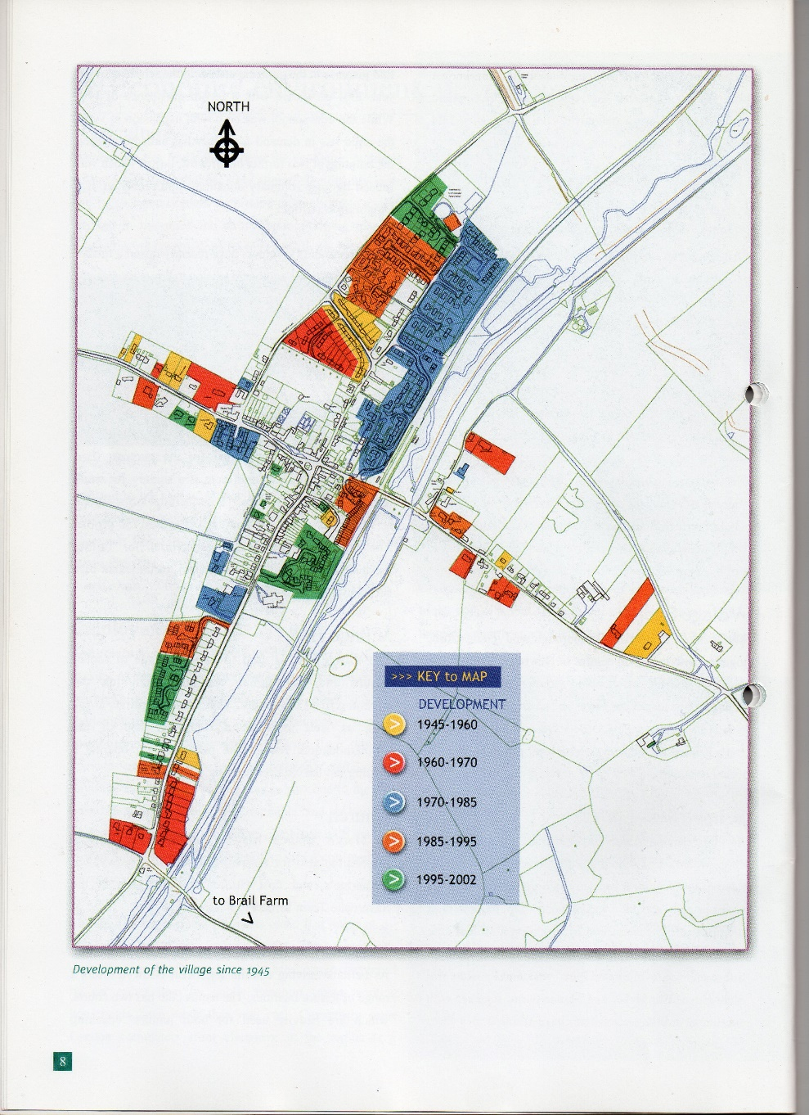

Because of building development in recent decades, there are now no remaining large development sites within the current Limits of Development, only a few small potential brown-field fill-in plots. There is a perceived shortage of one/two bedroom homes, affordable by younger members of local families. This is despite about one fifth of the homes in the village belonging to Housing Associations; at least two of the three biggest Associations do not intend to replace locally any of their homes which are sold to tenants from now on.

An imperative of the Great Bedwyn Neighbourhood Development Plan is therefore how sustainably to meet the demand for additional smaller homes, whilst on the other hand conserving the local environment.

GB Parish Council therefore set up a Working Group, in November 2015, to prepare a Neighbourhood Development Plan (NDP) for GB Civil Parish, to consult on what development within the settlement boundary is needed, to provide for sustainable residential and employment needs, and to conserve the environment, consistent with the Wiltshire Core Strategy [insert WCS reference].

Use by the WG of this 2nd draft scoping paper will lead to assessment and selection of options for inclusion in the eventual NDP, and other supporting sections thereof.

2. Framework of This Scoping:

To guide our NDP Sustainability Appraisal, and a Wiltshire Council Strategic Environmental Assessment (SEA) for this project; specifically to establish the context, objectives, baseline and scope of the appraisal which we must use, to the extent that the NDP policies will contribute to sustainable development in the GB Civil Parish.

Our definition of Sustainability:

Maintaining into the future for all our diverse community the balance between the required types and number of local homes, access to adequate employment, infrastructure and recreation, and conservation of the local rural environment.

Sources:
  - A Practical Guide to the Strategic Environmental Assessment Directive (ODPM, 2005).
  - Sustainability Appraisal Guidance (PAS) 2009).
  - Wiltshire Planning Authority.
  - Local plans, including the Wiltshire Core Strategy, the Kennet Conservation Assessment 2007, the Partnership Community Plan, and the GB Village Design Statement 2003.
- The Government’s Localism Act 2012.

The overall objectives:
  - To manage development by means of the NDP, in line with the Core Strategy and the housing needs of the community.
  - To ensure that the natural environment is conserved.
  - To ensure GB maintains its role as de facto minor Local Service Provider.
  - To ensure that all utility services meet the requirements of any future development.
  - To maintain and enhance the current green areas and sporting facilities.
  - To enhance the economic sustainability of the village.

The designated area to be covered is GB Civil Parish.

The sustainability appraisal and SEA processes are separate but overlap, and must give full consideration to environmental, social and economic factors.
The UK Government’s policy definition of sustainability and the five principles set out in their publication ‘Securing the Future: Delivering the UK Sustainability Development Strategy (2005)’ must be followed in this appraisal and assessment.
The UK Government’s intention to leave the European Union, much of whose legislation dictates current environmental, farming and other policies, means that this NDP is being developed in a situation of some political and regulatory uncertainty. Some EU directions may be incorporated into National regulations, or have already been so. So for the time being the NDP will also have to reflect what local landowners, farmers and other residents consider is best practice to maintain, improve and sustain land use in the Civil Parish. As NDP policies are developed, it will be essential keep in contact, through Wiltshire Council, with information from DEFRA, the Forestry Commission, Natural England, Historic England, North Wessex AONB, and the Environment Agency.
3. Methodology Required
Meeting Legal Requirements. Assessment (SEA) is required on plans which are determined likely to have significant environmental effects, in accordance with EU Directive 2001/42/EC “On the assessment of the effects of certain plans and programmes on the environment”, also known as the SEA Directive. The SEA Directive is transposed in England through ‘The Environmental Assessment of Plans and Programmes Regulations 2004’.

The likelihood of any significant environmental effects require an SEA from Wiltshire Council, throughout the NDP’s preparation.

SEA Directive 2001/42/EC legal requirements:
Setting the context and objectives; establishing the baseline; deciding on the scope.

The environment Report shall include information on (inter alia):

“The relationship (of the plan or programme) with other relevant plans and programmes” (Annex 1a)

“The environment protection objectives, established at international, European Community or national level. Which are relevant to the plans or programme and the way those objectives and any environmental considerations have been taken into account during its preparation” (Annex 1e)

“Relevant aspects of the current state of the environment and the likely evolution thereof without implementation of the plan or programmes” and “the environmental characteristics of areas likely to be significantly affected”) Annex 1 b and c)

“ Any existing environmental problems which are relevant to the plan or programme including, in particular, those relating to any areas of particular environmental importance, such as areas designated pursuant to Directives 79/409/EEC and
92/43/EEC” (Annex 1 d)

“The authorities which, by reason of their environmental responsibilities, are likely to be concerned by the environmental effects of implementing plans or programmes, shall be consulted when deciding on the scope and level of detail of the information which must be included in the environmental report” (Article 5.4 and 6.3)

4. Scope of draft Sustainability Appraisal Report

To establish key issues, information to be collected by the following means:
- Identifying relevant Plans, Policies and Programmes.
- Compiling baseline information.
- Identifying key sustainability and environmental issues and problems.
- Establishing appraisal objectives and a sustainability appraisal framework.

Following this initial scoping process, a Sustainability Appraisal Report (SAR) will be published for consultation alongside the draft NDP. This will assess any likely significant effects of the NDP. The sustainability topics considered in this document must cover not only those required by the SEA Directive but also any wider social and economic considerations.
The SEA Directive 2001/42/EC requires an assessment of:
“The likely significant effects on the environment, including on issues such as biodiversity, population, human health, fauna, flora, soil, water, air, climatic factors, material assets, cultural heritage including architectural heritage, landscape and the interrelationship between the above factors.”
The topic areas selected, including those relating to economic and social considerations, are:
- Biodiversity
- Land and soil resources
- Water resources and flood risk
- Air quality and Environmental pollution
- Climatic factors
- Historic environment
- Landscape
- Population and housing
- Community wellbeing and health • Education and skills etc.
- Service centre provision
- Transport
- Economy and enterprise
5. Identification of relevant policies, plans and programmes.
SEA Directive 2001/42/EC requires consideration of:
“The relationship with other relevant plans and programmes”
“The environment protect objectives, established at international, Community or Member State level, which are relevant to the plan or programme and the way those objectives and any environmental considerations have been taken into account during its preparation” (Annex1(a) and (e)
We must therefore toothcomb all relevant up to date policies, plans and documents which could influence our GBNDP to ensure that our policies and other proposals are consistent with those published by other. A résumé of such publications and key points is in the appendices. Because our policies and proposals are likely to be modest, some documents will be more relevant to a GBNDP than others.
Those policies, plans and programmes concerned include:
- National Planning Policy Framework (NPPF)
- Wiltshire Core Strategy 2016
- Wiltshire Infrastructure Delivery Plan 2011-2026 Appendix: Community Area Delivery Schedule
- Kennet District Local Plan 2011 Area
- River Avon Special Area of Conservation (SAC) Strategy 2003
- Wiltshire Biodiversity Action Plan (BAP) 2008
- An Air Quality Strategy for Wiltshire 2006
- Wiltshire and Swindon Waste Local plan 2011
- Wiltshire and Swindon Minerals Local Plan 2001
- Strategy for Historic Environment in the South West 2004
- Wiltshire Renewable Energy Action Plan
- Wiltshire Local Transport Plan 2006/7-2010/11
- The Wiltshire Strategy for 14-19 Education and Training 2005
- Wiltshire and Swindon Economic Strategy 2003-2008
- Kennet Landscape Conservation Strategy 2004
- North Wessex Downs AONB Management Plan 2002 (especially its Integrated Landscape Character Assessment Report)..
- Kennet District Council Housing Strategy 2004-2008
- A Strategy for Health, Kennet District Council 2004
- GB Village Design Statement 2003
- GB Conservation Area Character Appraisal and Management Proposals 2007

6. Baseline Information
SEA Directive 2001/42/EC requires consideration of:
“The relevant aspects of the current state of the environment and the likely evolution thereof without the implementation of the plan or programme and the environmental characteristics of areas likely to be significantly affected” (Annex 1(b) and (c)
“Baseline” means the characteristics of the current situation and important trends in the area covered by the Plan, based on sound evidence. This also provides the basis for prediction and monitoring of any environmental and sustainability effects of our Plan.
Gaps in data may be identified and in this process; local people, developers, advisors and statutory Consultees will provide information and feedback as neighbourhood planning progresses.
Many unlisted buildings that contribute towards local character (local materials and design vernacular) may be considered worthy of preservation in addition to those specifically ‘Listed’. New development must preserve such features and contribute to local character, in form, scale, materials and local design features.
Main points to be checked off in the review are set out in more detail in the appendices.

Appendix 1.
Publication, Plans and Programmes Reviewed by Topic with the Key Points Extracted

1 Biodiversity.
The importance of our region as a Special Area of Conservation (SAC), designated for its rare and vulnerable flora and fauna. Locally, the ancient and semi-natural wooded areas, and wetland habitat of the River Dun and the Kennet and Avon Canal are important.
Key Points/objectives
To ensure the sustainability and protection of the habitat of this area, the plan needs to take note of this objective and any effects development might have on it.
Relevant documents
a. Wiltshire Biodiversity Action plan (BAP) 2008
Outlines a strategic framework for the conservation and enhancement of Wiltshire’s habitats and species, includinge several protected types of bird, bat, dormice and crested newts. There are no specifically designated Sites of Special Scientific Interest (SSSI) in the Parish, but it borders Savernake Forest which has many SSSI.
Key Points/objectives
The protection of arable farmland, hedgerows, woodlands, ancient trees and chalk grasslands. The safeguarding of wildlife habitats from loss, degradation and fragmentation. Historic landscape and rides preservation.

The protection of the wetlands, woodlands, chalk grasslands and agricultural land.

The conservation of the lands of historic Tottenham Park.

Consistency with the 20-year Forestry Commission-supported management plan for Bedwyn and Wilton Brails.

Consistency throughout the Parish on hedgerow cutting, as recommended by Natural England (already controlled on some land by its Higher Level Stewardship funding agreements).
2. Land and Soil resources.

a. Wiltshire and Swindon Minerals Local Plan 2021.
This provides a sustainable land-use planning policy framework for waste management having regard to the best practicable options,
This plan reflects current government and European waste management policy and seeks to meet land use, planning needs and waste management.
3. Water Resources and Flood Risk.
a. Abstraction Management Strategy 2006.
The small River Dun is the only significant stream in the Parish, and is too small to be a major source of water extraction, but its water meadows support rare and in some cases threatened species.

The Kennet and Avon Canal is a major extractor of water from Wilton Water on the border of the Parish. Local water abstraction is subject to the Environment Agency’s Kennet and Vale of the White Horse Abstraction Licensing Strategy’.

There is a need to manage water abstraction to balance the water levels throughout the year.

Encourage sustainable use of water resources and minimise the need to consume new sources rather than make extra demands on the environment.

Use the opportunities offered by any new development to reduce causes and impact of flooding.

Identify land at risk from flooding and carry out flood risk assessments.
Avoid pollution of waters by chemical run-off.
4. Air Quality and Environmental Resources.

a. An Air Quality Strategy for Wiltshire 2006
This provides annual data for air quality measurements across Wiltshire and an air quality strategy.
Key points/objectives
Any development should comply with the strategy for air quality.
Account should be taken of air quality considerations when deciding planning applications and in particular when an increase in traffic is concerned.
- Climate Factors.
Whatever the causes, the reality of climate change, with effects of more intense rainfall and higher mean temperatures, both affecting drainage, flora and fauna.
a. Wiltshire Renewable Energy action Plan 2005.
This document sets out an action plan for the increase use of renewable energy across the County, and identifies the barriers to the deployment of renewable energy projects and seeks to address the procurement of renewable energy and to encourage the use of energy efficient buildings.

Key Points/objectives
All new homes to be zero carbon rated from now on.
Secure, especially for rural development, the fullest possible use of sustainable transport and reduce the need to travel particularly by car.
Promote the efficient use of energy whilst reducing energy demand.
Promote the energy efficient design of buildings and ensure that their location mitigates the effects of climate change.
6 Historic Environment.
- Strategy for the Historic Environment in the South West 2004.
This strategy emphasizes the contribution of the historic environment, the quality of life and culture of the region.
It sets out a vision for the management of these historic resources.
Key Points/objectives
Consideration of the historic environment and its sustainable management.
Promotes the sensitive design of buildings appropriate to their location.
Promotes the use of traditional conservation and management skills.
- Pewsey Area Conservation Area Character Appraisal and Management Proposals 2007

7. Landscape
a. Kennet Landscape Conservation Strategy 2003
This strategy describes the main landscape character within the former Kennet District.
Conserve the landscape which is of a high scenic quality and which is generally unspoilt and in a good condition.
Improve landscapes which have been affected by intense farming, Dutch Elm and other tree diseases, and non agricultural activity.
Reduce visually intrusive development.
Protect and improve the quality of the countryside.
b. North Wessex Downs AONB Management Plan 2002.
This plan identifies issues affecting the management of the area and sets out how they can be addressed.
It offers a vision of the future of the area and practical action to achieve it.
Conserving and enhancing the landscape character, heritage and biodiversity within the AONB.
Sustaining natural resources and promoting low carbon economy.
8. Population and Housing.
Wiltshire Council Revised Plan (awaited)
Building Strong Foundations, Wiltshire Housing Strategy 2011-2008
These are statements of how the County Council will endeavour to fulfil their housing duties.
Provision of affordable housing
Improve the condition of local housing stock
Catering for an increasing elderly population
Develop communities with local employment opportunities.
Improve viability and vitality of town centres.
Support local facilities in villages.
Aid the restructuring of rural economies by promoting and accommodating diversification.
Facilitate the provision of appropriate levels of affordable housing.
- Wiltshire Core Strategy Document 2016.
This plan sets out Wiltshire’s housing policy until 2026 including GB Community Area.
The number of dwellings to be built in GB Community Area by 2026 is virtually nil, but housing pressure in S England may change this well before 2026.
GB Parish Is a de facto local Service Centre. Awaiting settlement review by WC.

- Wiltshire Infrastructure Delivery Plan 2011-2026 Appendix 1: Community Area Delivery Schedules Pewsey Area.
This schedules the infrastructure requirements identified by service providers as necessary to support development in the Core Strategy.
BT Rollout of superfast Broadband
Review need for extension of existing primary schools
Review need for improvements and extension to small GP surgery in village
Small scale capacity improvements to water supply and waste networks.
Kennet and Avon phased towpath improvement and maintenance
Improved and enhanced indoor and outdoor leisure facilities.
Provision of youth recreational facilities.
Improvement to walking and cycling routes, public transport services and associated facilities.
Improved access particularly for pedestrians, cyclists and buses to GB Station, and roads giving access to houses away from village centre.
e. The National Planning Policy Framework (NPPF) 2012
This is the latest government policy on planning and development and which supersedes much of these existing legislation. As this is National policy it is applicable in general guidance terms at local level. It does, of course, apply in one important point to this venture by giving parish councils the right to produce a Neighbourhood Development Plan.
9. Community Wellbeing and Health.
a. A Strategy for Health, Kennet District Council 2004.
This Strategy supported the Wiltshire county Council stated aim to make Wiltshire the healthiest county in which to live by 2012.
Key Points/objectives
Promote and support adequate health services in all community areas.
Advocates the retention of community hospitals in Marlborough.
Ensure that health services are appropriate and accessible to all residents.
Maintain and enforce the highest standards of public health.
Provide a range of recreational facilities.
Implement housing and homeless strategies.
b. Pewsey Community Area Plan – The Future 2008-2018.
GB is under Pewsey Area Board. A community prepared plan for the community area by the local strategic partnership covering all areas of socio-economic activity. Its vision is that the area will continue to be a beautiful and pleasant natural environment with a strong community spirit and plenty of local involvement.
Key Points/objectives
It is a living and working environment.
GB village acts as a de facto minor service centre for the area providing access to education, health, social care, retail outlets and employment.
Services both public and private are covered.
Recreational and cultural facilities are outlined and supported.
Transport and development are covered.
The plan identifies current problems, aspirations and resolutions for the future.
- GB Community Resources– A working Village.
The GBNDP must consider the use of land for the community and identifies potential sites for community facilities in the Parish.
10. Education and Skills.
a. The Wiltshire Strategy for 14-19 years Education and Training.
This strategy sets out the principles and expectations applicable to the development of 14-19 year olds’ education and training in Wiltshire.
To raise achievement and attainment at all levels .
To increase participation in education and training at these ages.
To support the development of partnerships and collaboration as a means to increase opportunities and the inclusion of apprenticeships in employment training.
Relevance of this document to the GB NDP: The NDP should be aware of the educational plans for Pewsey, in considering development sites.
- Area Service Centre Provision.
Not yet recognised by WC so stress in NDP.
- Transport.
a. Wiltshire Local Transport Plan 2006/7.
This plan steers the development of national transport policy in Wiltshire and addresses county transport policy.
Key Points/objectives
To improve access for goods and services and employment opportunities, especially in rural areas.
To respond to the increasing number of vehicles, roads and road safety.
To reduce speeding.
To maintain an integrated public transport network.
To provide a satisfactory bus service especially in rural areas.
To improve facilities for cyclists and pedestrians
Relevance of this document to the GBNDP: The NDP has to be aware of the effect on traffic of any planned development in GB area and to note the above objectives.
13. Economy and Enterprise.
a. Wiltshire and Swindon Economic Strategy 2003 -2008.
This is aimed at improving economic wellbeing whilst having regard to the environment, ensuring the vitality of rural areas and improving the quality of life of the community.
Encouraging sustainable development by increasing investment in employment and services, and ensuring sustainable economic growth.

Appendix 2

Additional Environmental and Sustainability Think Points for Possible Reflection in Plan
Topic 1 Biodiversity
- Development could, if not strictly controlled, seriously affect nature and balance of countryside.
- Sites of Special Scientific Interest require protection
- Some Water Meadows are areas of wildlife conservation which require protection, similarly green areas designated as ‘minimal change’.
- Green areas used for school and sporting activities and allotments could be threatened; these also support biodiversity
- Farming and other rural activities are vital to the area. The present move towards diversification is important both economically and environmentally whilst protecting agricultural land. (1)
Topic 2 Land and Soil resources
- There is pressure on maintaining the settlement boundary.
- Windfall sites within the settlement boundary have been and will continue to be used for development.
- To develop outside the settlement boundary, away from the village, would mean the use of greenfield/agricultural land which could adversely affect the AONB, id too much in sensitive environmental sites.
- The present employment sites are near to full capacity. Expansion of the current sites should also be considered even if it means that, by exception there is a need to use a site outside the settlement boundary.(2)
- Any future development should be at a minimal density to protect the nature of the village.
- The use of brownfield sites should be maximised.(3)
Topic 3 Water resources and flood risk
- There are two important water resources in GB, i.e. the river Dun and the Kennet and Avon canal and the integrity of both have to be protected from any adverse affect from development and water levels maintained.
(1) North Wessex Downs AONB Management Plan
(2) Wiltshire Core Strategy Pre-Submission Document 2012
(3) NPPF 2012.
- Abstraction must be strictly controlled and there should be no adverse affect on local water meadows and the Canal.
- There is an increase in the risk of flooding through climate change in some areas of GB. This requires monitoring and suitable protection employed for any development.
- The disposal of waste foul water must be considered in any new development.
- River/canal pollution is a risk to be considered.
Topic 4 Air Quality and Environmental Pollution
- The considerable increase in transient heavy goods vehicles affects air quality adversely.
- There should be as little increase in traffic, especially HGVs, as possible.
- There is a risk of the water systems becoming polluted.
Topic 5 Climatic Factors
- As a result of climate change weather patterns are altering. The effects of this change may impact on water supply, flood risk, food production, energy use, transportation and a number of other areas.
- Planning and development policies will need to focus on mitigating the effect of climate change.
- New residential, economic and mixed use developments should employ renewable energy and energy saving techniques.
Topic 6 Historic Environment
- There are a number of features within the area that require protection for their heritage and archaeological value.
- The conservation area must be protected and preserved from any inappropriate development.
- Historic village and rural landscapes are important and require protection.
- Local heritage assets are a tourist attraction which should be encouraged and enhanced.
Topic 7 Landscapes
- The GB landscape is one prime reason for the North Wessex Down’s AONB designation and this should be conserved and enhanced to preserve the natural beauty of the area. (1)
- Rights of way and byways add to the appreciation of the landscape and should not be disturbed by new developments.
The chalk downs and woodlands are of particular significance and require specific management. (1)
- There is a close inter-relationship between the landscape quality and the value of wildlife habitats.
- The important special individual quality of the landscape is a tourist attraction which supports the local economy.
Topic 8 Population and Housing
- There has been significant housing development within GB within the last 20 years of a variety and size of housing.
- GB has a mixture of architectural types examples of which are set out in the Village Design Statement, this mix should be sustained particularly in the conservation area. (Kennet Conservation Assessment 2007)
- All listed buildings should be protected, and those identified by WC as being of architectural interest
- Windfall sites have been used within the settlement boundary but there are few others yet to be developed.
- Affordable housing has been included in recent developments and more is required to allow local people to remain in GB area.
- The village rail station allows daily travel to London and the South West which tends to inflate house prices making the provision of affordable housing more important.
Topic 9 Community Wellbeing and Health
- There are facilities within the village which cater for the elderly and those that require care; consideration and monitoring is needed to see if provision is sufficient for the ageing population.
- There is a need to consider if the available primary care is sufficient in the light of recent increase in housing and is secondary care reasonably accessible
- There is insufficient and adequate accommodation for some community activities.
- There is a selection of sports facilities and clubs which should be protected. However, a suitable site for a skateboard park, and other facilities for under 18’s, are still needed.
- GB has a limited range of services required by the public. These must be retained and enhanced if possible.
- The Wiltshire Campus programme is being adopted in Pewsey which may increase and improve access to public services there.
Topic 10 Education and Skills
- There is no secondary education in GB and pupils have to travel to attend these classes elswhere.
- There is no provision and therefore little opportunity for adult education in the area.
- Apprenticeships should be encouraged to provide employment and to help local industry.
- There is sufficient school capacity for recent development, but future development may require an increase.
Topic 11 Service Centre Provision
- Maintaining and enhancing retail outlets.
- Sustaining the viability of the village centre and resisting the conversion of shops and offices into residential.
- Ensuring that there are sufficient sites from which services can be provided.
- Attract new and different services to the village centre.
- Ensure that there are sufficient employment sites from which services can be provided.
Topic 12 Transport
- This rural area is heavily dependent on cars and public transport to access bigger service centres.
- The provision of free parking should be maintained but this will become increasingly difficult as the volume of traffic increases. Additional car parking facilities are required.
- The increase in vehicles using an undesignated NW/SE freight route, between the A338 and the A4, causes damage to the roads and dangers for residents.
Public transport links with train arrivals should be maintained and enhanced.
- There is a recognised need for safety features like pedestrian crossings which are costly and although in the Highway programme have yet to be funded.
- The current train timetable especially with through running trains to London must be maintained and if possible improved.
- The general increase in traffic is detrimental to the environment, conservation areas, small villages, rural roads and any new development should recognise this problem and not make it worse.
- The increase in road vehicles, even if outside the area covered by the plan, may have a detrimental impact and should be recognised.
Topic 13 Economy and Enterprise
- Current employment sites are, although not full, reaching capacity and more may be needed.
- Businesses and retail, especially in the village centre, should be encouraged and enhanced. New enterprises require support.
- Free car parking is a way to support trade and should be continued, but needs to be taken into account in a parking plan.
- There is a significant proportion of daily commuters, but there is also an increase in working from home as travelling becomes more expensive.
- The trend for rural diversification by conversion of out-buildings etc to employment sites should be encouraged.
- This area lends itself to the tourist industry which should be encouraged.
- There is a shortage of tourist accommodation and toilets for visitors.
- The canal is a prime tourist asset and users should be encouraged to use the village facilities, when open.

Appendix 3

2 blank pages for insertion of summary of key documentary and oral evidence already gathered (including that displayed on Open Day posters) and from whom gathered, as basis of evidence list in eventual NDP report

GBNDPSUSSCOP 3RD Draft 30/12/16
GBNDPSUSSCOP 3RD Draft 30/12/16
GBNDPSUSSCOP 3RD Draft 30/12/16
GBNDPSUSSCOP 3RD Draft 30/12/16
GBNDPSUSSCOP 3RD Draft 30/12/16
GBNDPSUSSCOP 3RD Draft 30/12/16
GBNDPSUSSCOP 3RD Draft 30/12/16
GBNDPSUSSCOP 3RD Draft 30/12/16
GBNDPSUSSCOP 3RD Draft 30/12/16
GBNDPSUSSCOP 3RD Draft 30/12/16
GBNDPSUSSCOP 3RD Draft 30/12/16
GBNDPSUSSCOP 3RD Draft 30/12/16

